**Katherine Lamoureux HW6**

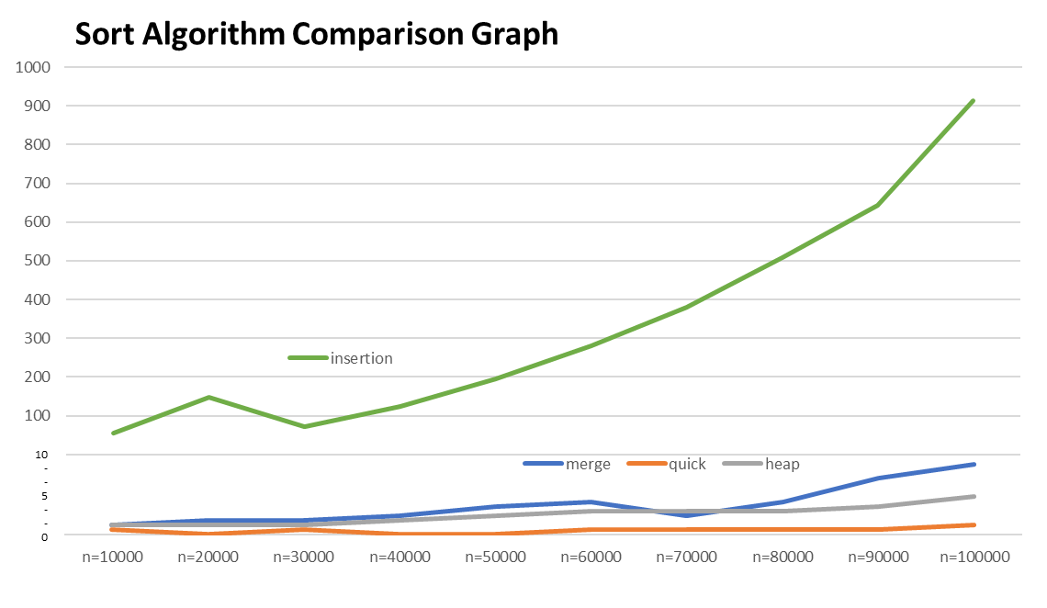

**Analysis:** After graphing my SortingComparison.java output, I determined that insertion sort is quadratic time O(n^2). Merge and Heap are Linear Time O(n). And Quick Sort is Constant Time O(1) or a slow growing Linear Time O(n). Quick sort is the best method to use. Raw data output is below.

|  |  |  |  |  |  |  |  |  |  |  |
| --- | --- | --- | --- | --- | --- | --- | --- | --- | --- | --- |
|  | 10000 | 20000 | 30000 | 40000 | 50000 | 60000 | 70000 | 80000 | 90000 | 100000 |
| insertion | 55 | 147 | 72 | 124 | 194 | 280 | 380 | 508 | 643 | 914 |
| merge | 2 | 3 | 3 | 4 | 6 | 7 | 4 | 7 | 12 | 15 |
| quick | 1 | 0 | 1 | 0 | 0 | 1 | 1 | 1 | 1 | 2 |
| heap | 2 | 2 | 2 | 3 | 4 | 5 | 5 | 5 | 6 | 8 |

**SortingComparison.java Output**